**Que 1) Plot a histogram,**

**10, 13, 18, 22, 27, 32, 38, 40, 45, 51, 56, 57, 88, 90, 92, 94, 99**

Answer 1:

|  |  |
| --- | --- |
| **Frequency Table** | |
| Class | Count |
| 0-19 | 3 |
| 20-39 | 4 |
| 40-59 | 5 |
| 60-79 | 0 |
| 80-99 | 5 |

Summary

|  |  |
| --- | --- |
| Mean | 51.2941 |
| Standard Deviation (s) | 30.7227 |
| Class Range | 20 |
| Bins | 5 |

**Que 2) In a quant test of the CAT Exam, the population standard deviation is known to be 100. A sample of 25 tests taken has a mean of 520. Construct an 80% CI about the mean.**

Answer 2: Compute and 80% Confidence Interval:

Sample size (n) = 520

Sample mean (X̄) = 25

Sample Standard Deviation (σ or s) = 100

Confidence Level = 80%

Formula: CI = X̄ ± Z*s/SQRT(n)

CI = 25 ± 1.2816*100/√520

CI = 25 ± 5.620

***Therefore, an 80% confidence interval about the mean is [19.380 – 30.620].***

**Que 3) A car believes that the percentage of citizens in city ABC that owns a vehicle is 60% or less. A sales manager disagrees with this. He conducted a hypothesis testing surveying 250 residents & found that 170 residents responded yes to owning a vehicle.**

1. **State the null & alternate hypothesis.**
2. **At a 10% significance level, is there enough evidence to support the idea that vehicle owner in ABC city is 60% or less.**

Answer 3:

a. Set up the Hypothesis Test (Left Tailed)

Null Hypothesis (H0): p ≤ 0.60

Alternative Hypothesis (H1): p > 0.60

The 10% level of significance means that α = 0.10.

b. In this case, we should use One population proportion Z-test method:

so, $\hat{p}=\frac{X}{n}=\frac{170}{250}$

$Thus, sample proportion, p ̂=0.68$,

p = 0.60, population proportion, and

Z statistics at 10% level of significance i.e., Z = 1.282

***Formula:***

Z **= $\frac{\hat{p}-p}{\sqrt{\frac{p(1-p)}{n} }}$**

$$⇒Z=\frac{0.68-0.60}{\sqrt{\frac{0.60(1-0.60)}{250} }}$$

$$⇒Z=\frac{0.08}{\sqrt{\frac{0.60(0.4)}{250} }}$$

$$⇒Z=\frac{0.08}{\sqrt{\frac{0.24}{250} }}$$

$$⇒Z=\frac{0.08}{\sqrt{0.00096}}$$

$Thus, Z=2.582$

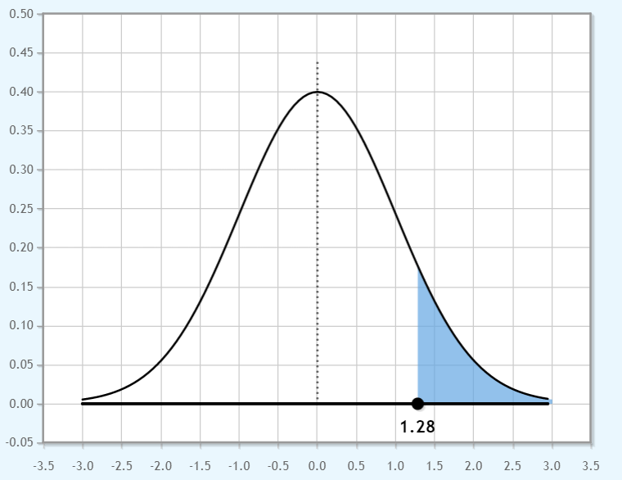

**So, Zcalculated > Ztabulated i.e., 2.582 > 1.282, reject H0 and support alternative hypothesis.**

**Interpretation**: Since, 2.582 > 1.28, so we have sufficient evidence to reject H0. Hence, at alpha level is 10%, it is likely to seems that the vehicle owner in ABC city is more than 60%.

**Que 4) What is the value of the 99 percentile?**

**2,2,3,4,5,5,5,6,7,8,8,8,8,8,9,9,10,11,11,12**

Answer 4: There are 20 observations in the given data.

P99 =

=

=

P99 = or index.

Thus, 20.79th index position indication shown at the end of the data i.e., 12.

**Hence, the value of the P99 is 12.**

**Note:** No data is available for 21st position, so we take only 12.

**Que 5) In left & right-skewed data, what is the relationship between mean, median & mode?**

**Draw the graph to represent the same.**

Answer 5: In a perfectly symmetrical distribution or normal distribution or bell-shaped curve, the mean and the median are the same i.e., Mean = Median = Mode (see below).

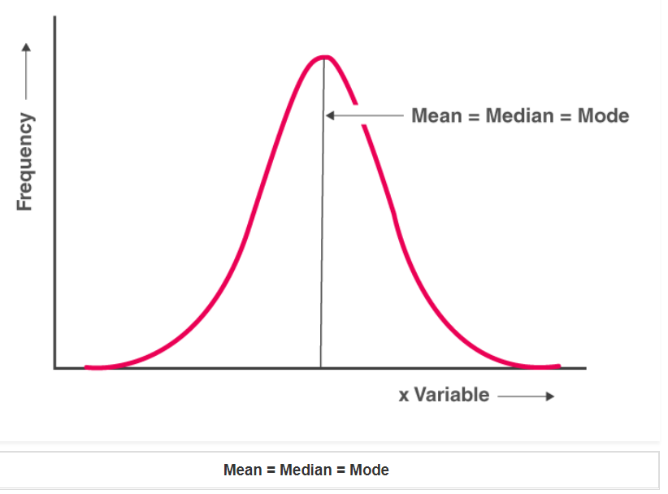

In case of a positively skewed (right-tail) frequency distribution, the mean is always greater than median and the median is always greater than the mode i.e., Mean > Median > Mode (see below).

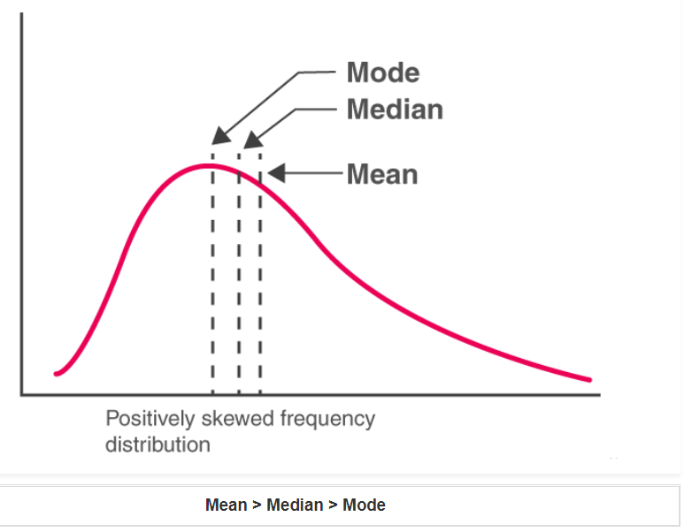

On the other hand, a negatively skewed (left-tail) frequency distribution, the mean is always lesser than median and the median is always lesser than the mode i.e., Mean < Median < Mode (see below).

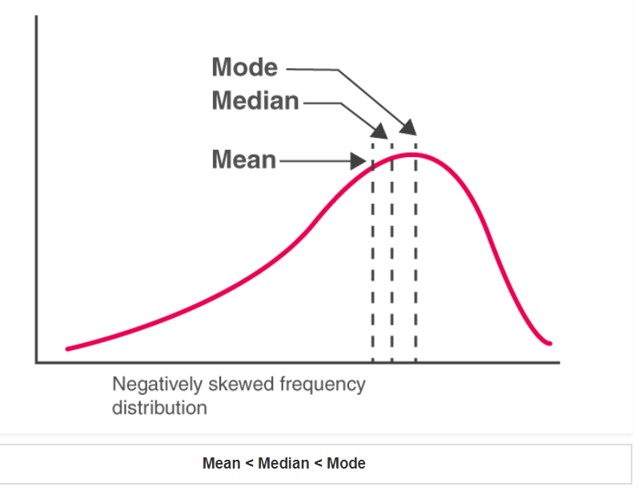

To summarize, generally if the distribution of data is skewed to the left, the mean is less than the median, which is often less than the mode. If the distribution of data is skewed to the right, the mode is often less than the median, which is less than the mean. Below are the distributions for negatively, positively, and no skewed curves in one frame.

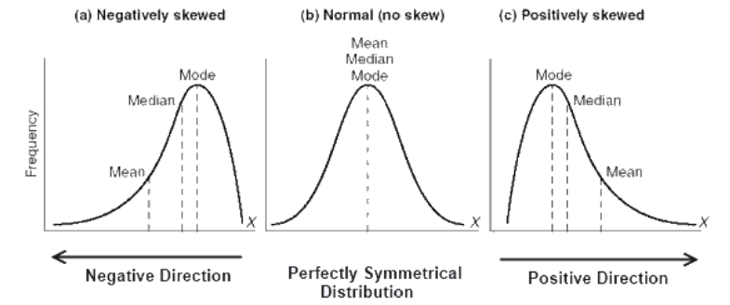

**THANK YOU!**